Endurance Robotics PT-3
www.endurance-robotics.com
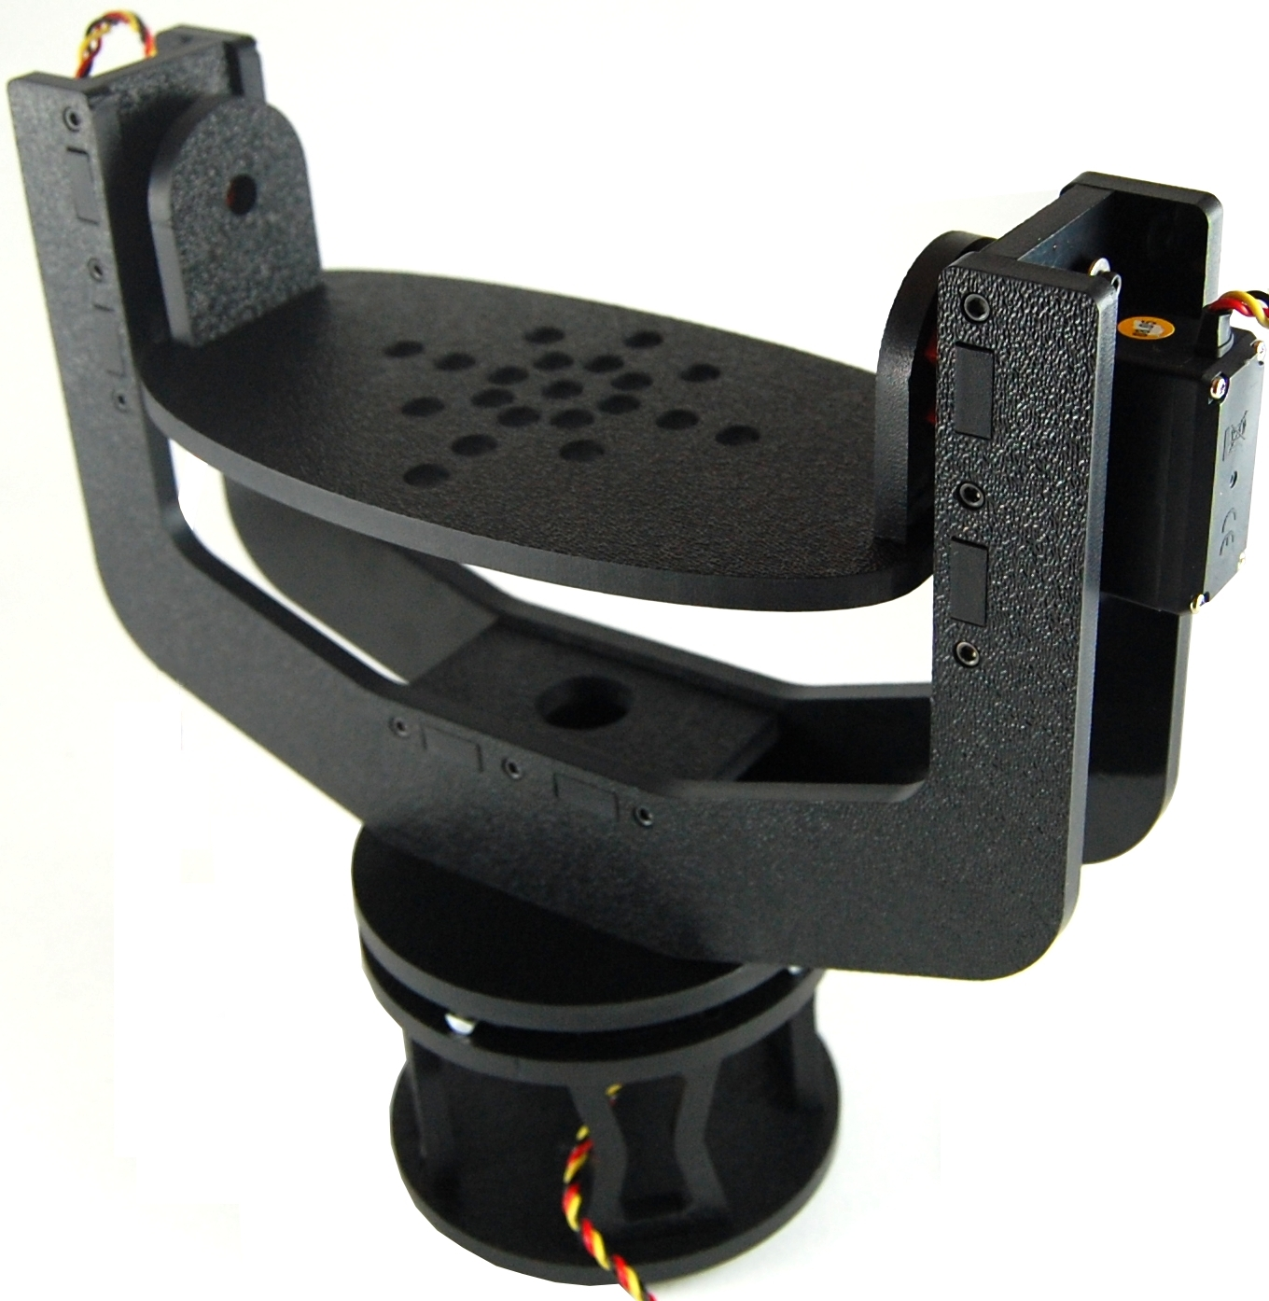

The Endurance Robotics Pan and Tilt PT-3 base is a rugged pan and tilt system based around standard sized hobby servos. Featuring all around rigid 1/4" ABS laser cut construction, the PT-3 base is perfect for general use R/C, robotics, hobby, and photography applications. The PT-3 is capable of handling most pocket sized cameras as well as larger SLR’s and video cameras.

Kit Contents:
- 2x Pan Bracket
- 1x Pan Bracket Spacer
- 2x Tilt Bracket
- 2x Tilt Hub Support
- 1x Tripod Mount
- 1x Tilt Top Plate
- 1x Bottom Plate
- 4x Mount Support
- 1x Pan and Tilt Mounting Bracket
- 1x Pan Base Plate
- 72x Socket Head Screws
- 30x Washers
- 4x Ball Bearings
- 4x Ball Bearing Mounts

Required Extras:
- 3x Standard Size Hitec Servos. (Other servos can be used but Hitec is recommended for hub compatibility)
- R/C Radio System or Computer Based Servo Controller
- 5-6V Battery
Assembly Instructions

Parts required for step 1:
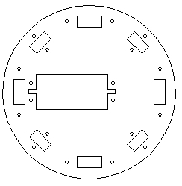 | 1x Pan and Tilt Mounting Plate
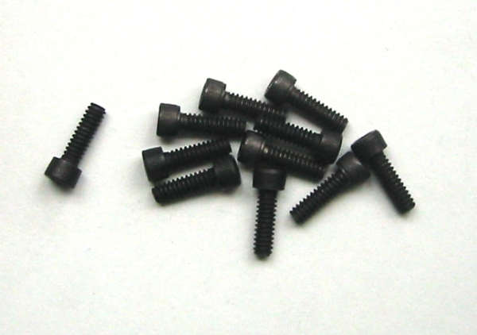 | 4x Socket Head Screws
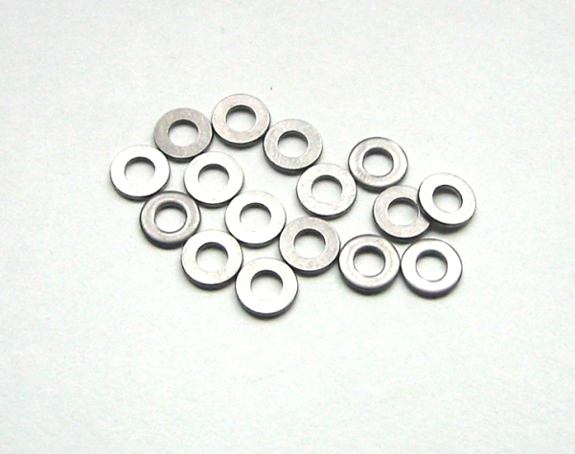 | 12x Washers

- Orient the Pan and Tilt Mounting Plate with the textured side facing down. Place a washer on to a screw and place it through the bottom side of a servo mounting hole. Use 3x washers to offset the servo and loosely tighten the screw to the plate. Make sure that the servo output shaft is towards the center of the plate. Repeat the process for the remaining three holes.

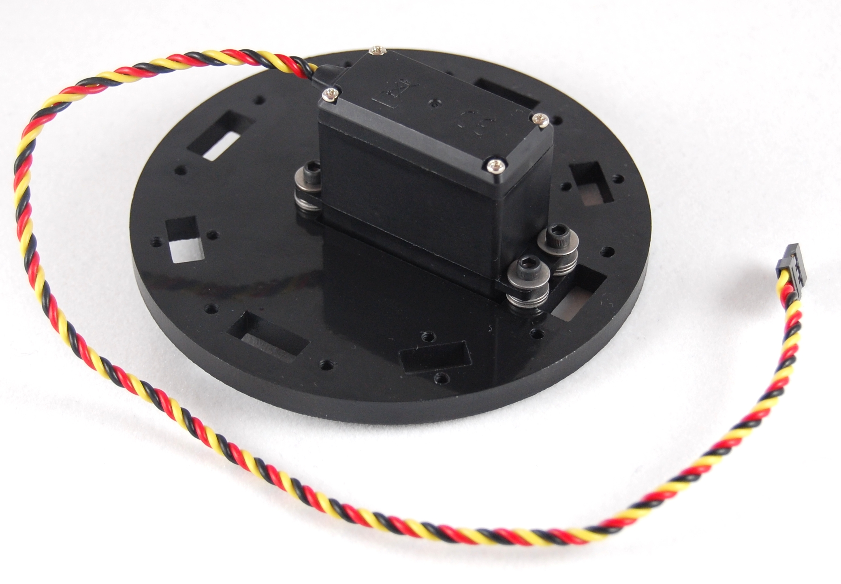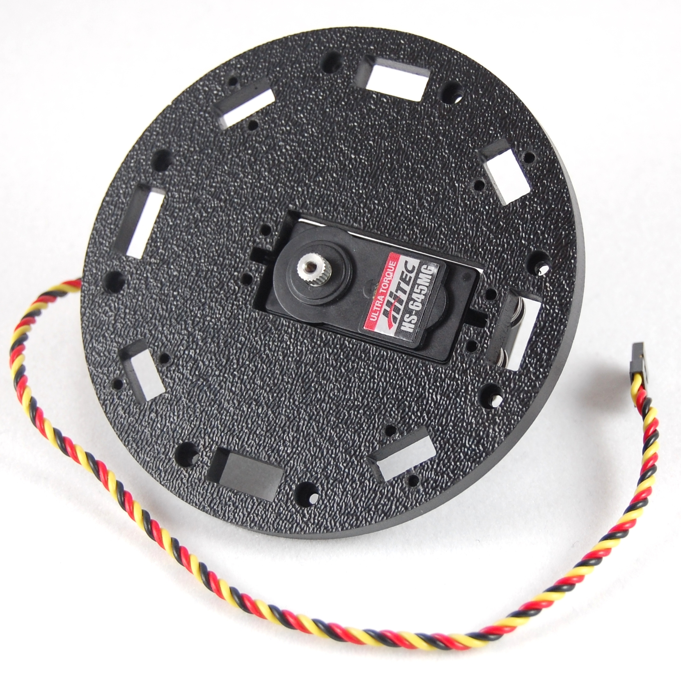
Step 1.

Parts required for step 2:
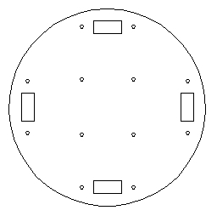 | 1x Bottom Plate
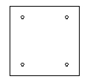 | 1x Tripod Mount
 | 4x Socket Head Screws

- You will notice that two sides of the Tripod Mount are beveled. Orient the Tripod Mount to the Bottom Plate with the beveled edges facing towards the plate. Secure the Tripod Mount to the Bottom Plate with 4x Socket Head Screws. Note the orientation of the bevels. This will mark the front/rear of the PT-3.
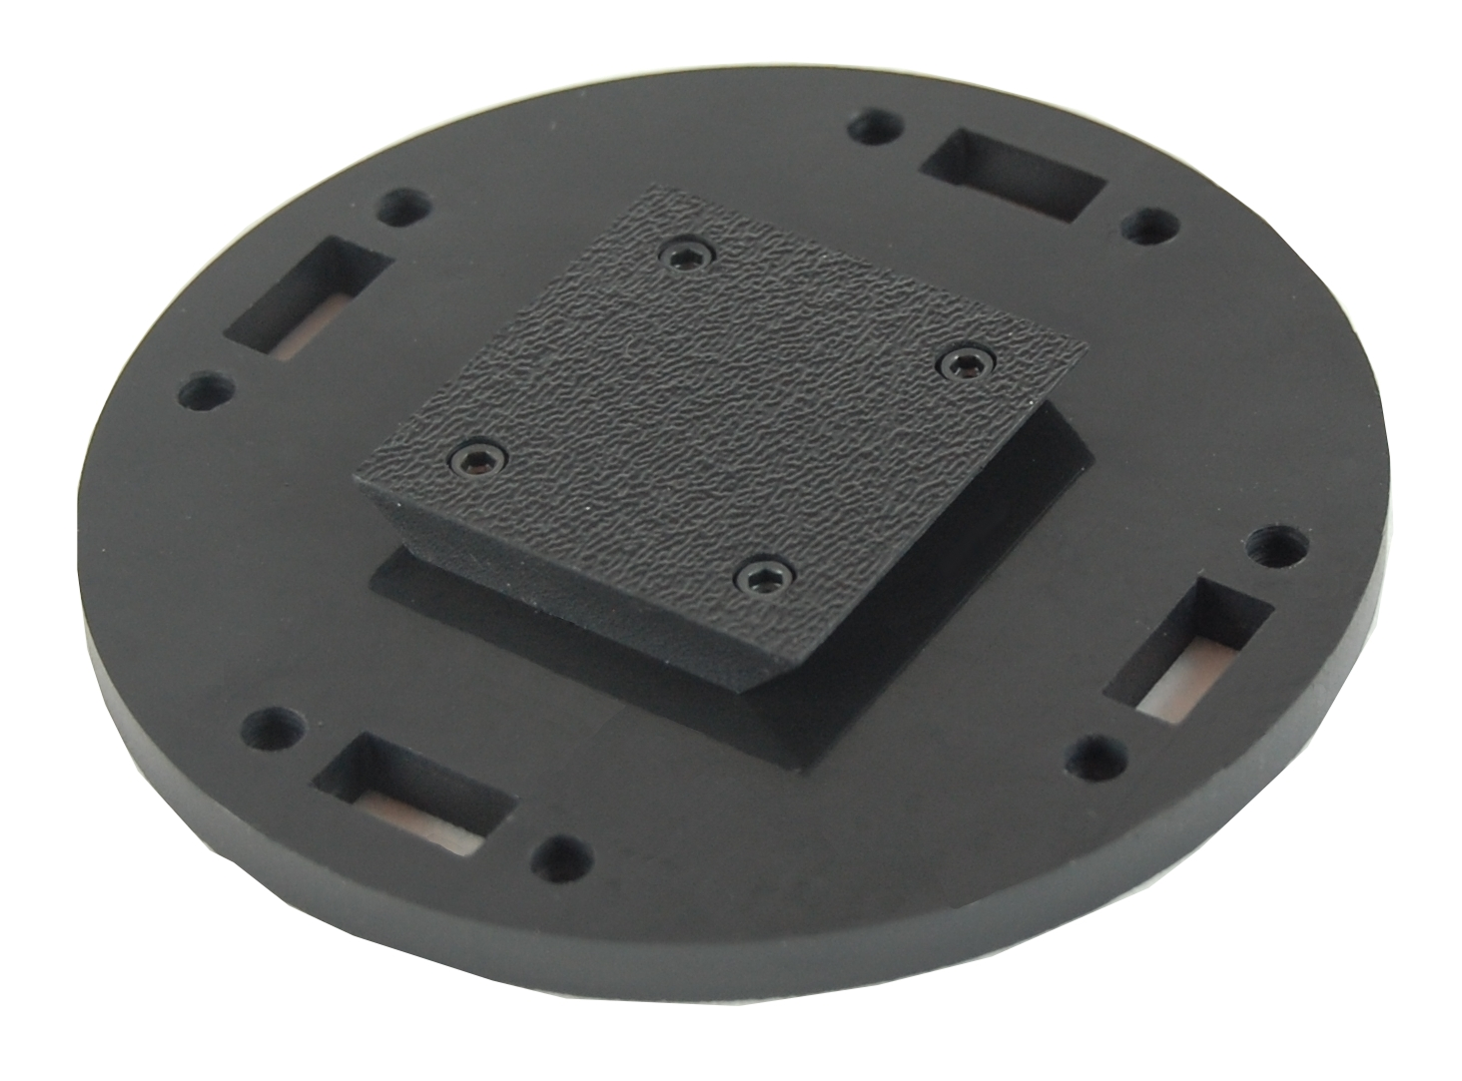
Step 2.

Parts required for step 3:
8x Socket Head Screws
1x Bottom assembly from Step 2.
- Insert the 4x Mount Supports into the notches on the Bottom assembly. Orient the Mount Supports with the textured side facing out. Attach with 8x Socket Head Screws.
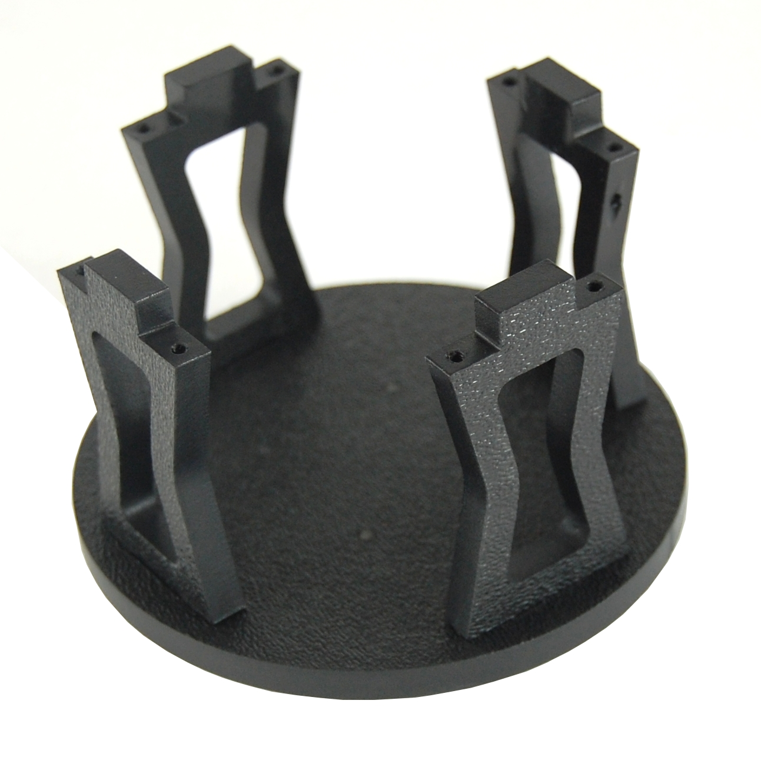
Step 3.

Parts required for step 4:
8x Socket Head Screws
All Assemblies from previous steps
- Connect the Top and Bottom assembly with 8x Socket Head Screws.

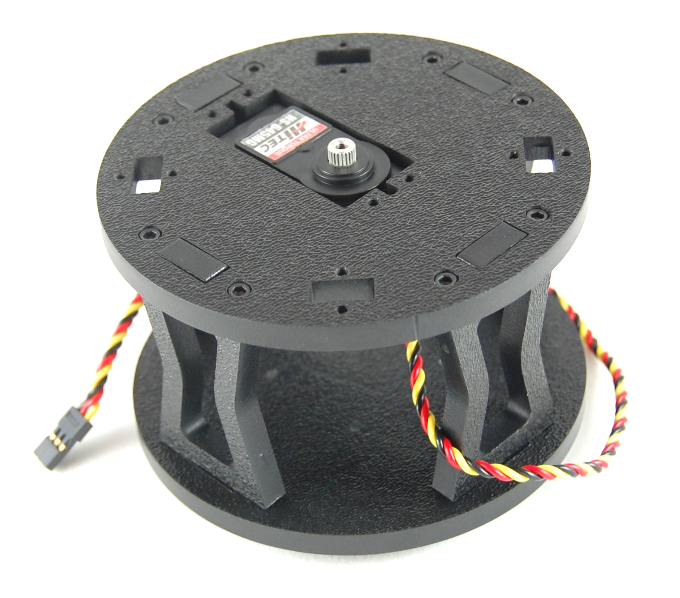

Step 4.
Parts required for step 5:
8x Socket Head Screws
4x Ball Bearings
4x Ball Bearing Mounts
- Place a Ball Bearing on to each of the 4x Ball Bearing Mounts. Screw each bearing to the Pan assembly.

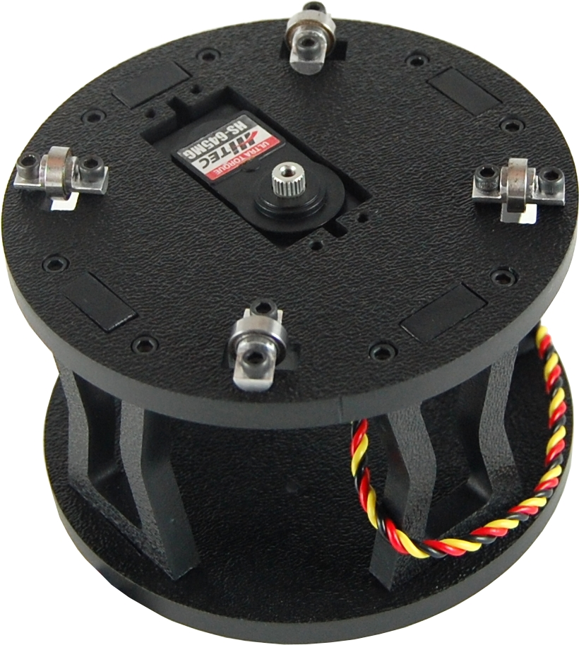

Step 5.

Parts required for step 6:
 | 8x Socket Head Screws
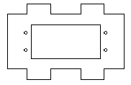 | 2x Pan Bracket
 | 2x Servos
- Place one Pan Bracket with the textured side facing down. Insert a servo, output shaft first, through the hole and secure with 4x Socket Head Screws and washers. Repeat for the opposite side.

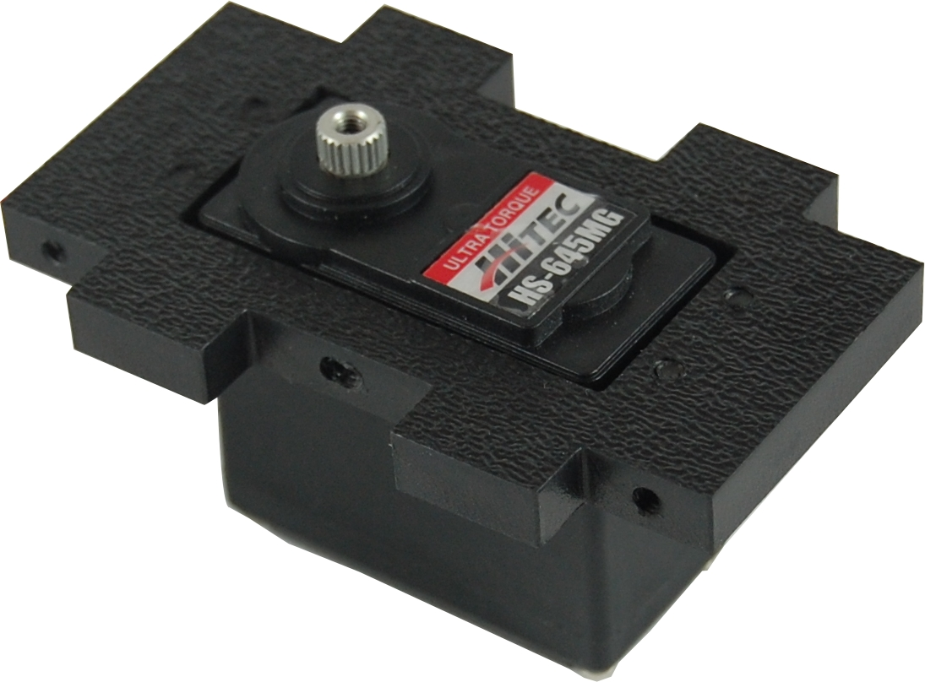 | 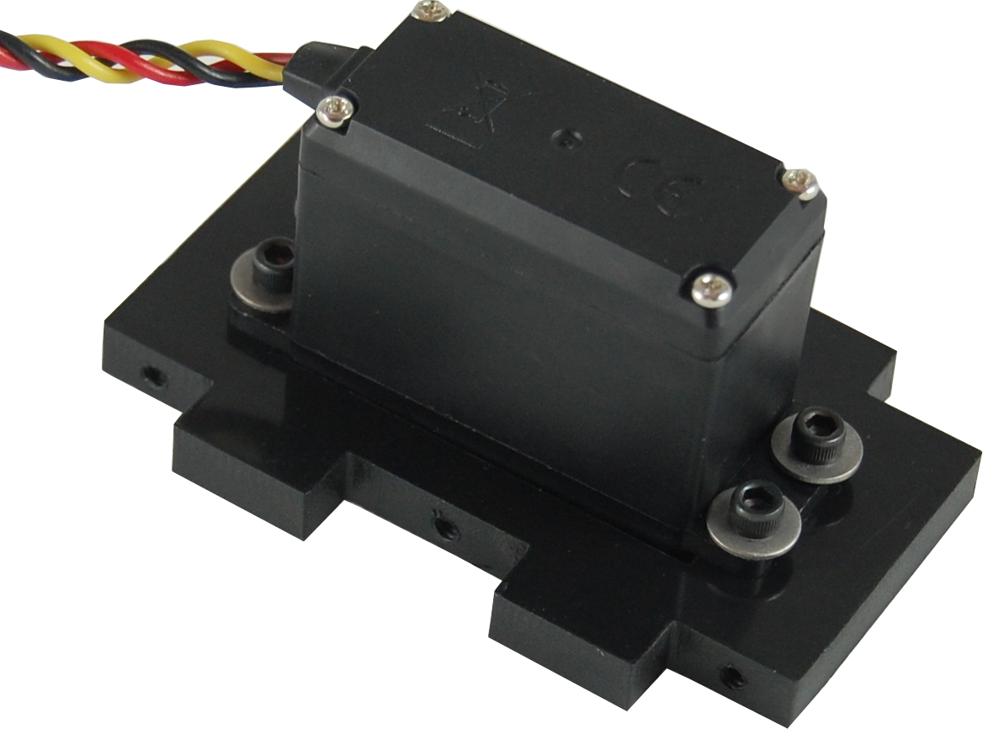

Step 6.
Parts required for step 7:
 | 6x Socket Head Screws
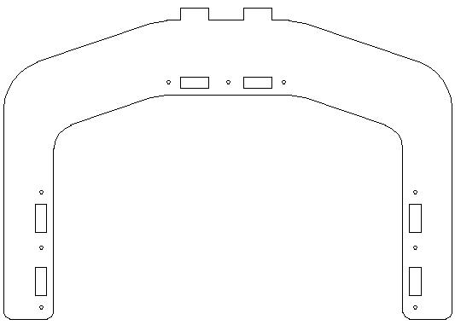 | 1x Pan Bracket
 | 2x Pan Bracket Assembly from step 6.
- Place the Pan Bracket with the textured side facing down. Insert the two Servo assemblies from step 6 into the left and right slots. Orient the servos so that the output shafts are facing in and towards the top of the Pan Bracket. Secure each assembly with 3x Socket Head Screws.

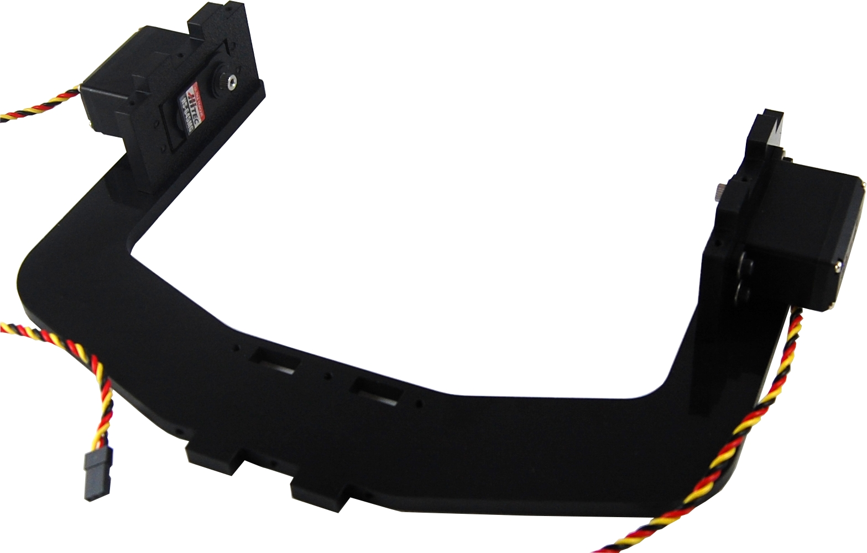

Step 7.
Parts required for step 8:
 | 3x Socket Head Screws
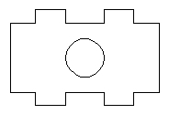 | 1x Pan Bracket Spacer
 | 1x Assembly from Step 7.

- Insert the Pan Bracket Spacer into the bottom of the Tilt Bracket with the textured side facing up towards the servos. Secure with 3x Socket Head Screws.

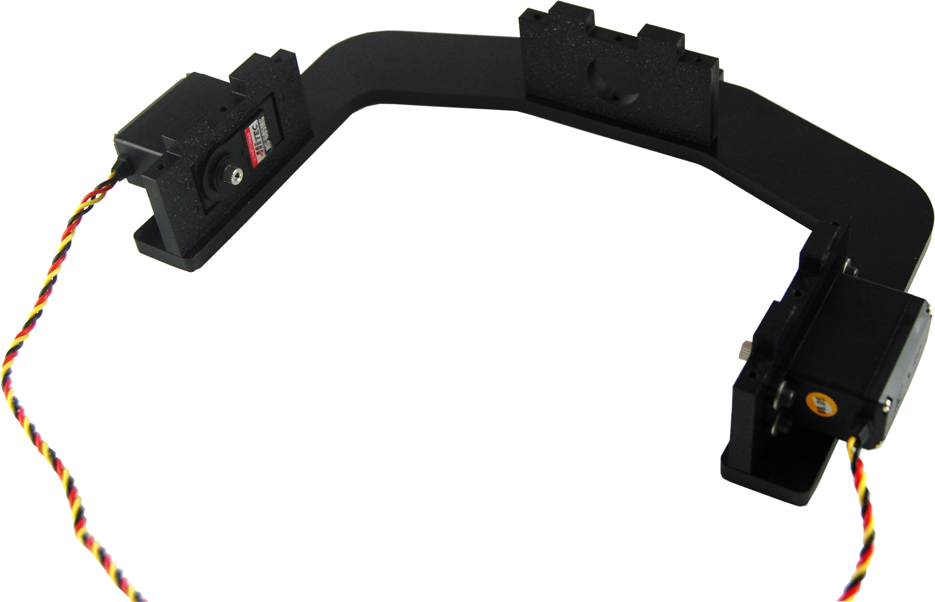

Step 8.

Parts required for step 9:
9x Socket Head Screws
1x Pan Bracket Spacer
1x Assembly from Step 8.

- Install the opposite side of the Pan Bracket to the existing assembly with 9x Socket Head Screws.

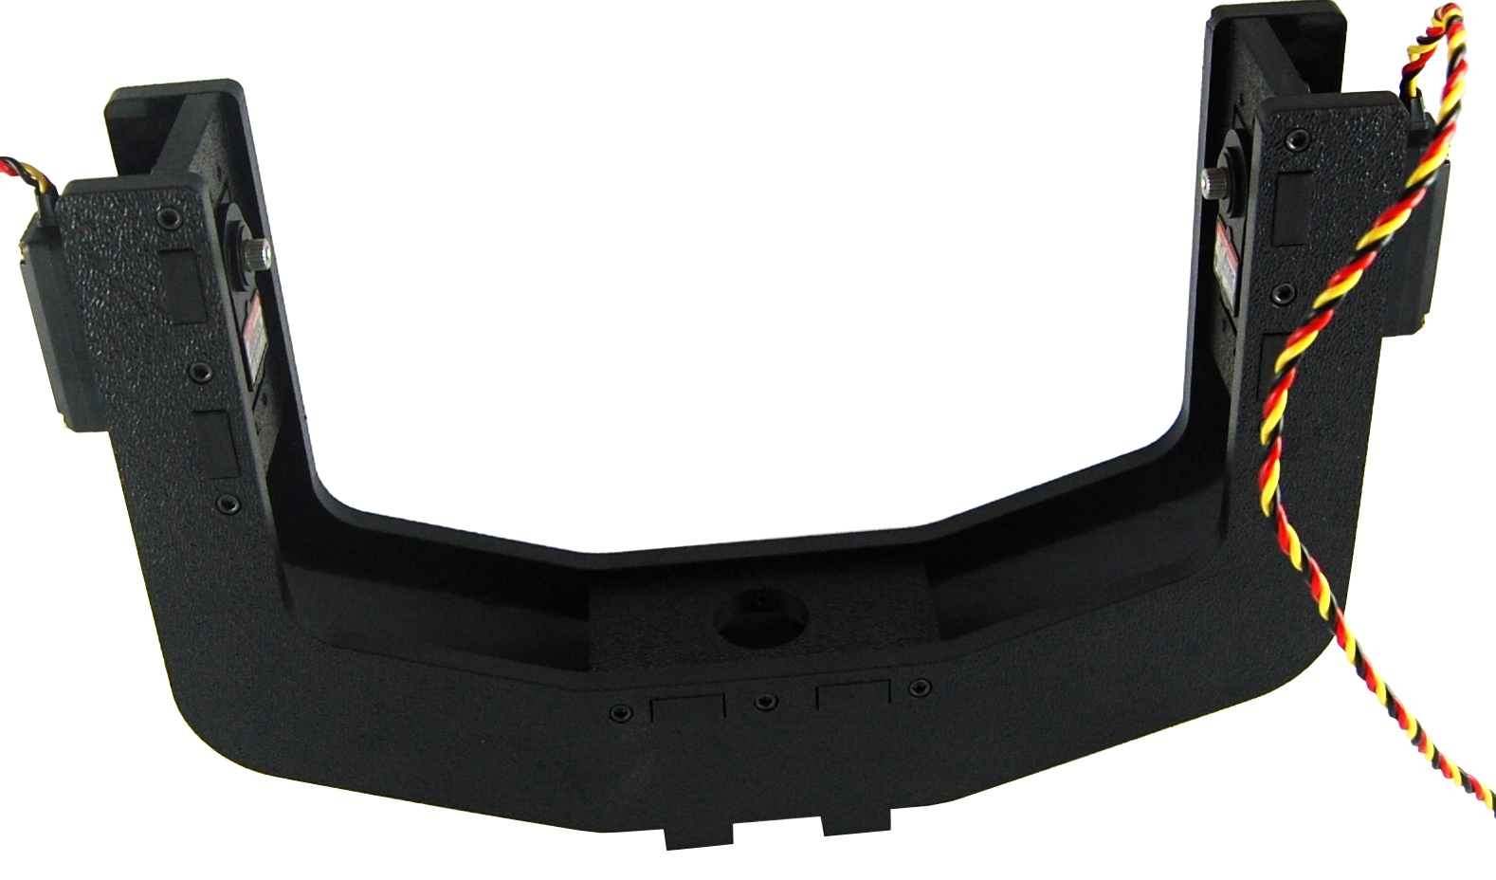

Step 9.
Parts required for step 10:
 | 4x Socket Head Screws
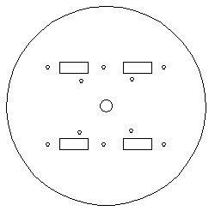 | 1x Pan Base Plate
 | 2x Washers
 | 1x Servo Output Horn
- Attach a Servo Output Horn to the Pan Base Plate with 4x Socket Head Screws. Use washers on the two thinner arms of the horn. Optionally drill out the holes in the servo horn with a 7/64” bit.
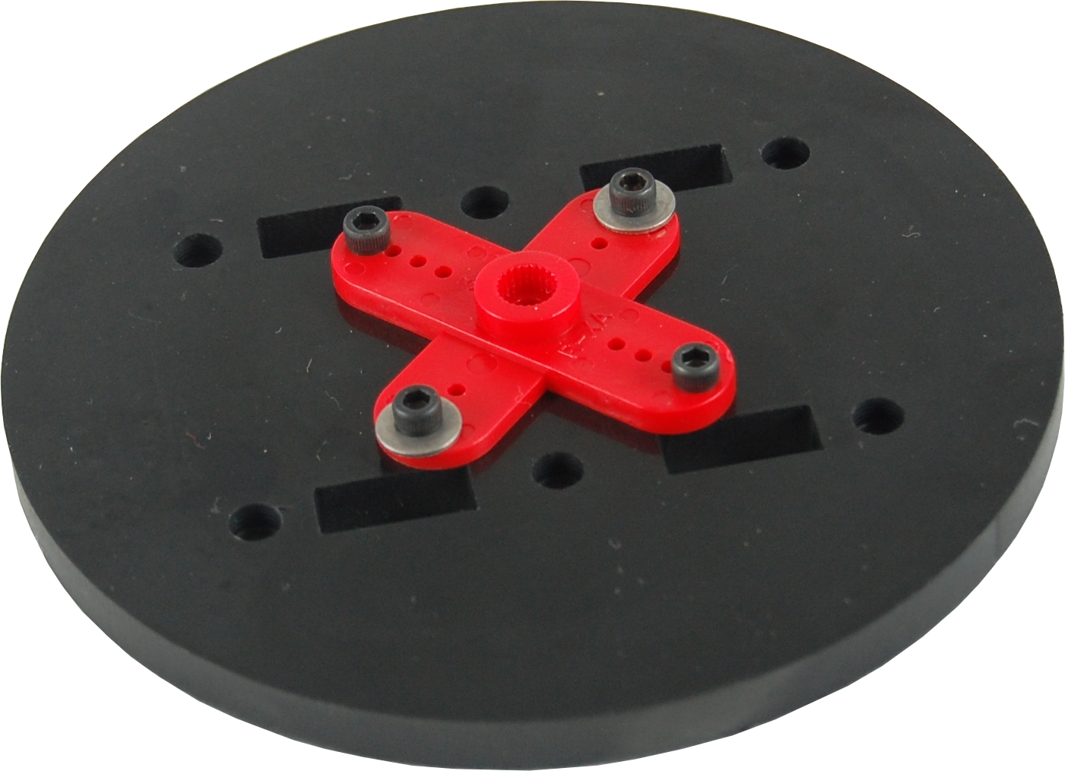
Step 10.
Parts required for step 11:
6x Socket Head Screws
1x Assembly from step 9.
1x Assembly from step 10.
- Connect the Pan Base Plate to the pan assembly with 6x Socket Head Screws.
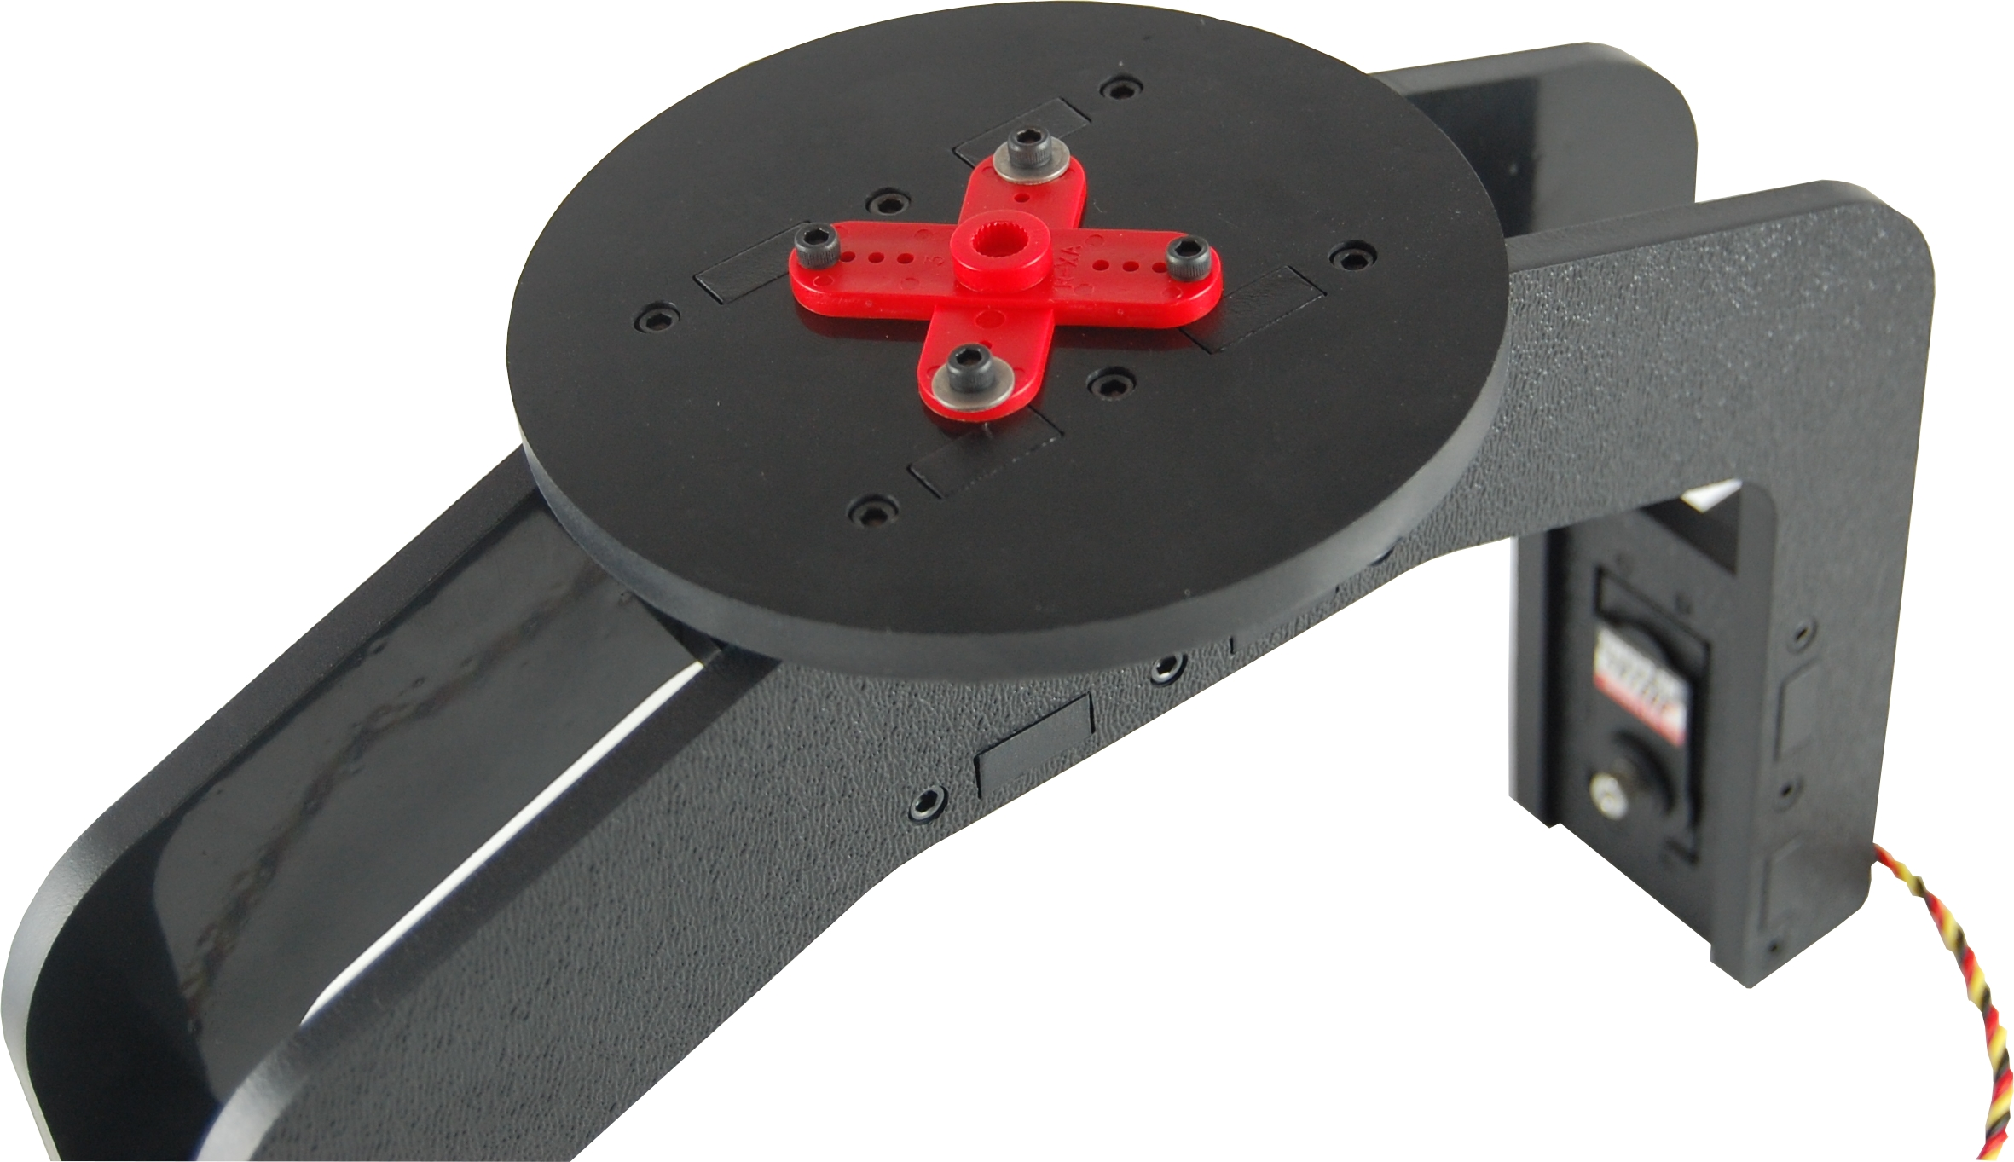
Step 11.
Parts required for step 12:
1x Lower pan assembly from step 5.
1x Upper pan assembly from step 11.

- Orient the servo output shaft so it is at its center position. Connect the upper pan assembly to the lower pan assembly with the supplied servo screw. Make sure that the front of the upper assembly is in line with the bevels on the bottom of the tripod mount if installed. Once secured rotate the upper assembly to verify it is spinning freely.

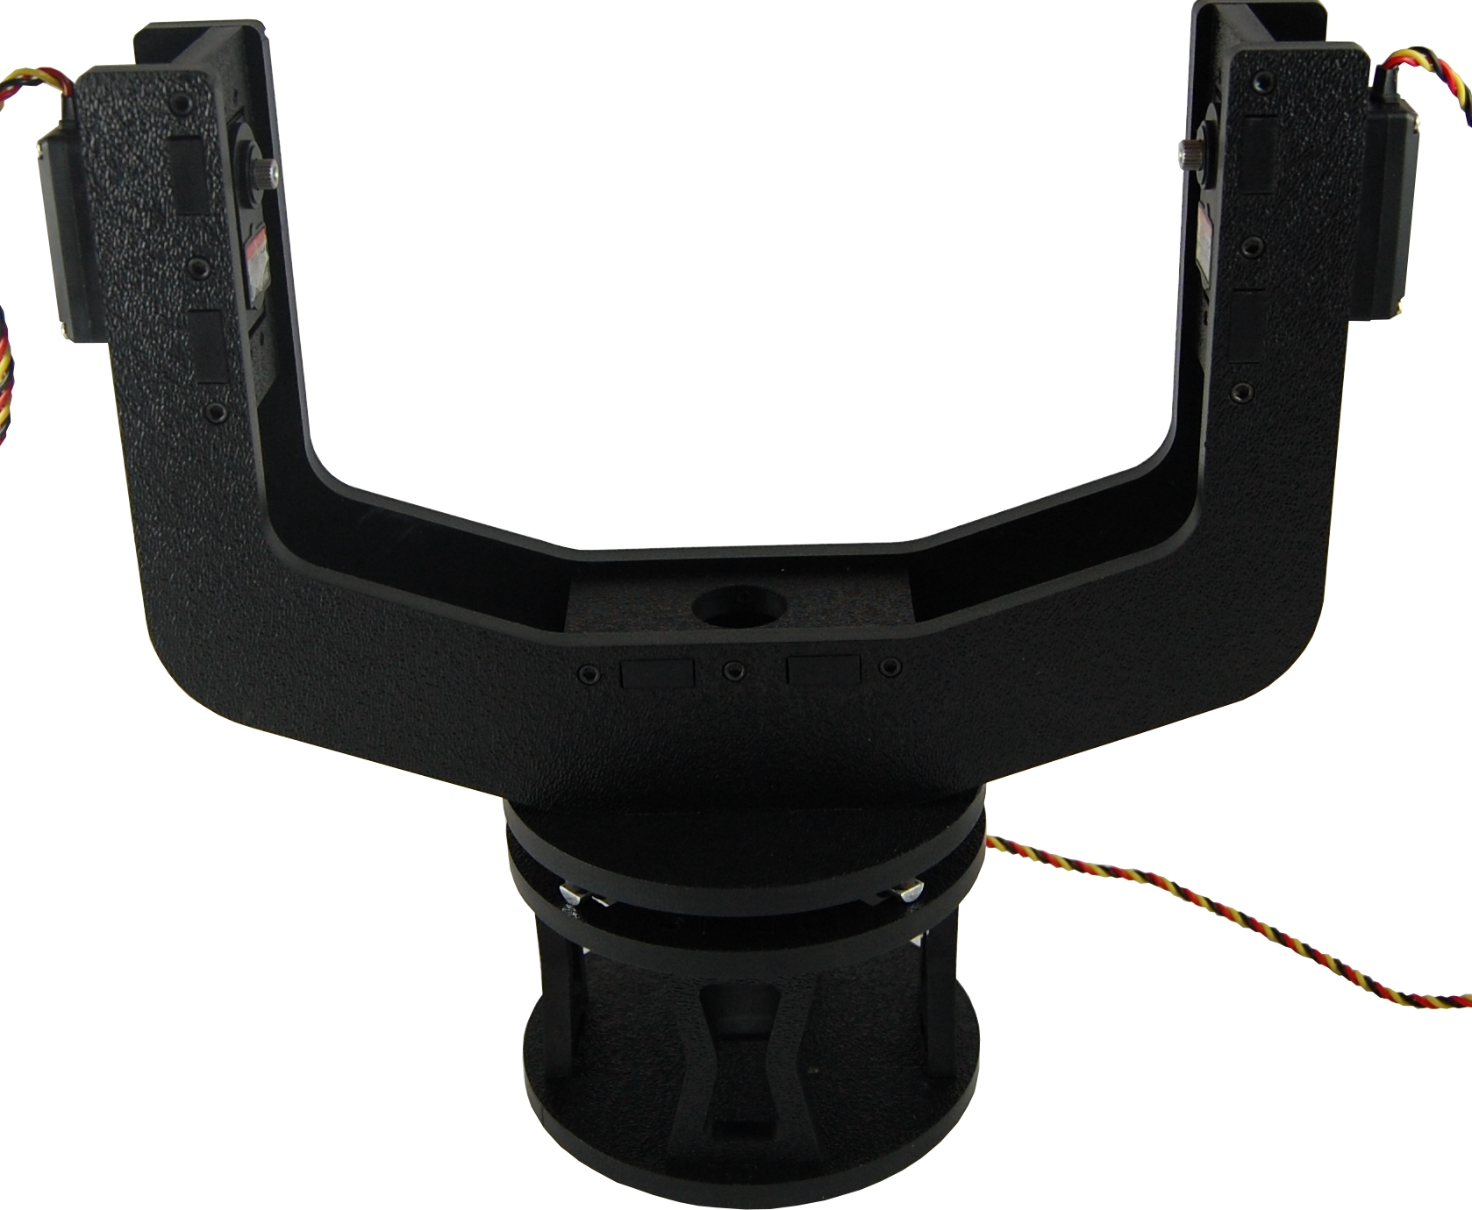

Step 12.
Parts required for step 13:
 | 8x Socket Head Screws
 | 4x Washers
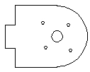 | 2x Tilt Support Hubs
 | 2x Servo output horns

- Before instillation you may optionally cut the servo output horn arms down to the second hole from the shaft center. Drill out holes with a 7/64” bit if desired.

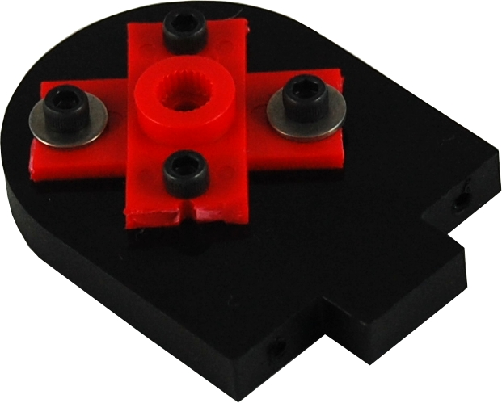
Step 13.
Parts required for step 14:
 | 4x Socket Head Screws
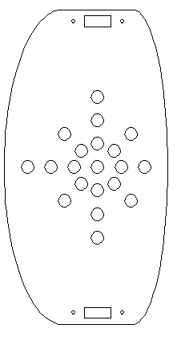 | 1x Tilt Top Plate
 | 2x Tilt Support Hubs from step 13.

- Orient the Tilt Top Plate with the textured side facing up. Insert the two Tilt Support Hubs into the plate with the output horn side facing out. Secure each hub with 2x Socket Head Screws.

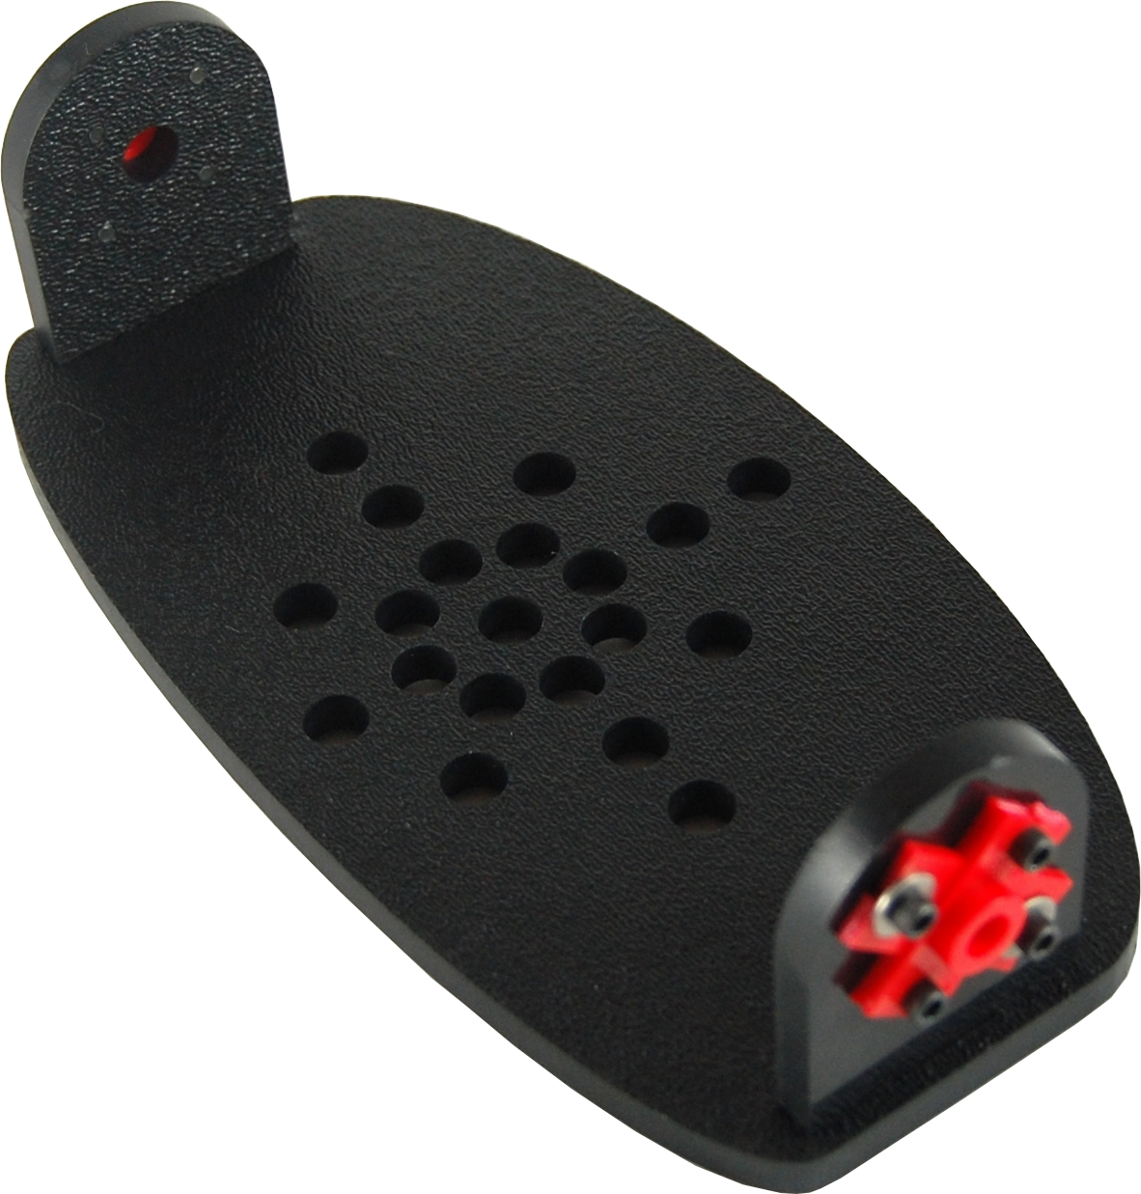
Step 14.
Parts required for step 15:
1x Assembly from step 12.
1x Assembly from step 14.

- Turn each servo output shaft on the upper pan assembly to the center position. Insert one side of the tilt assembly into a servo output shaft. Be sure to insert the tilt assembly at a horizontal position. Slightly bend the upper pan assembly arm and insert the opposite end of the tilt assembly on to the servo output shaft. Verify that the tilt platform rotates to the limits of the servos. Secure with the supplied servo screws.

Step 15. Completed PT-3 Pan and Tilt Base

